Task 1:

Recap of Last session:

Create a file names 21st May.txt and push it to your git hub.

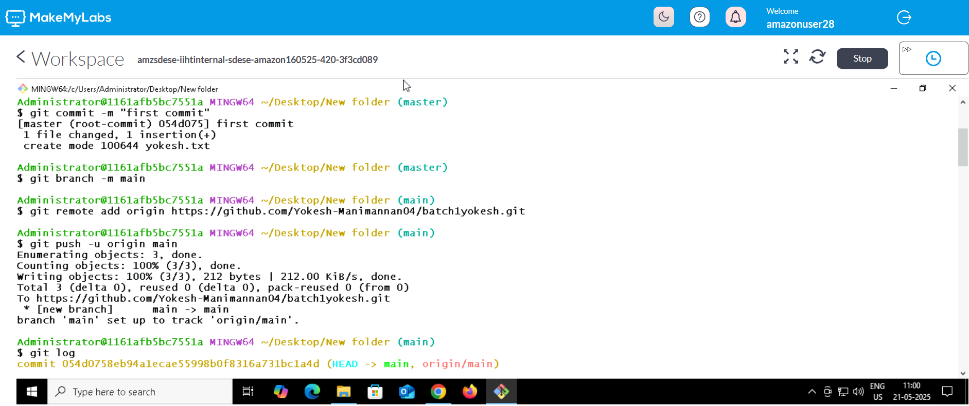

Task 2 : Branch

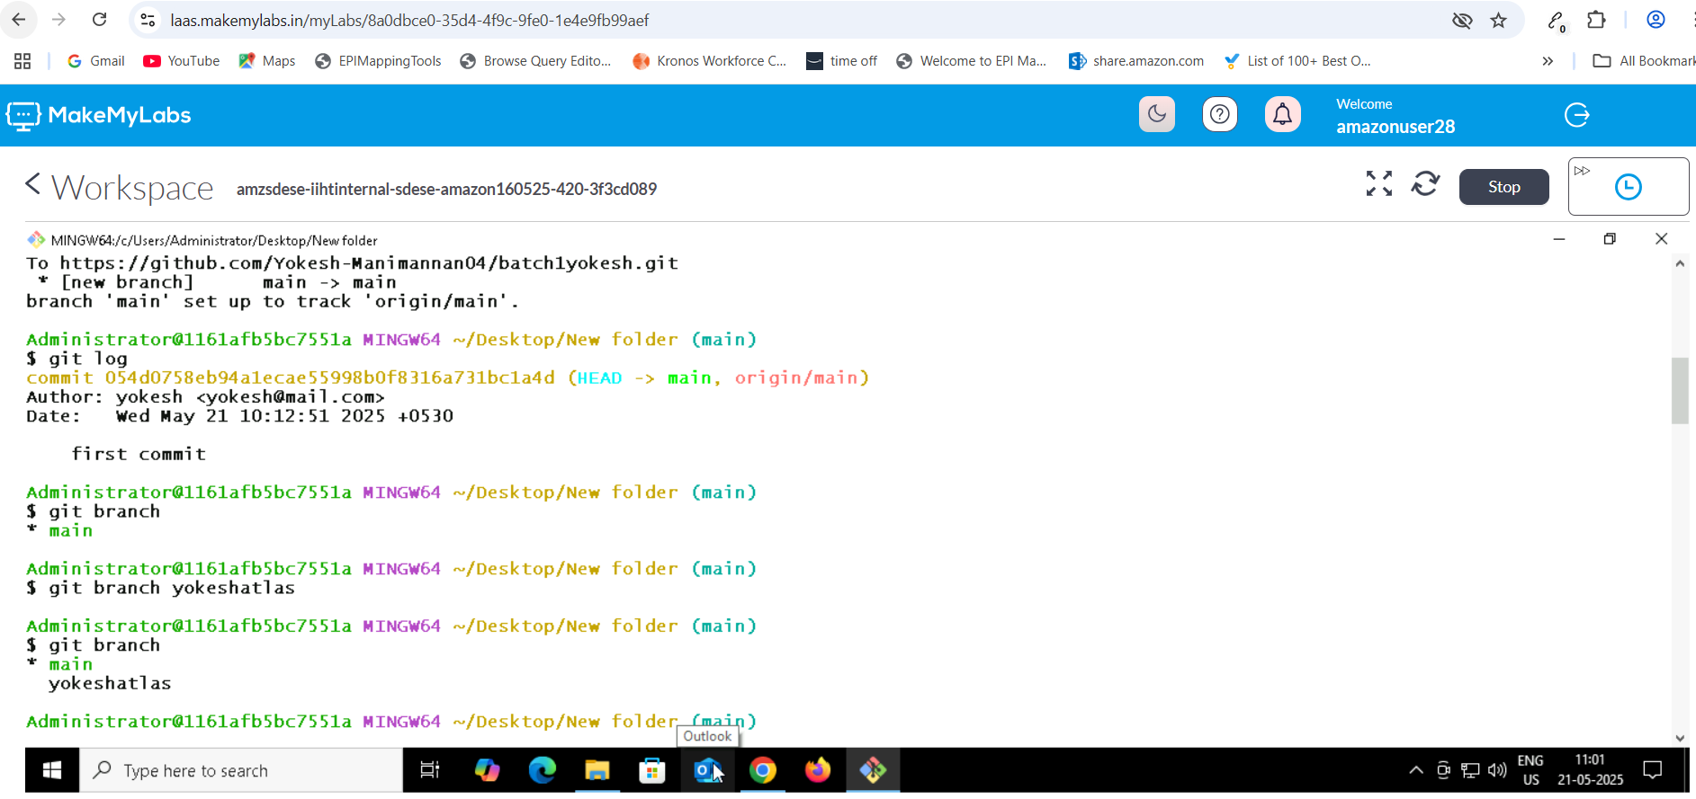

Branch merge

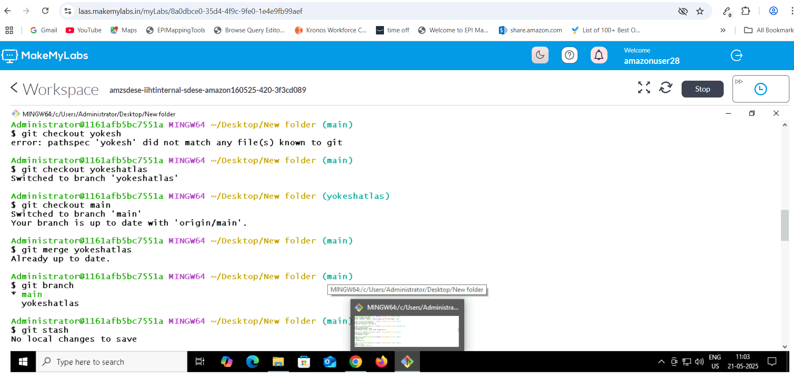

Task : GIT tag

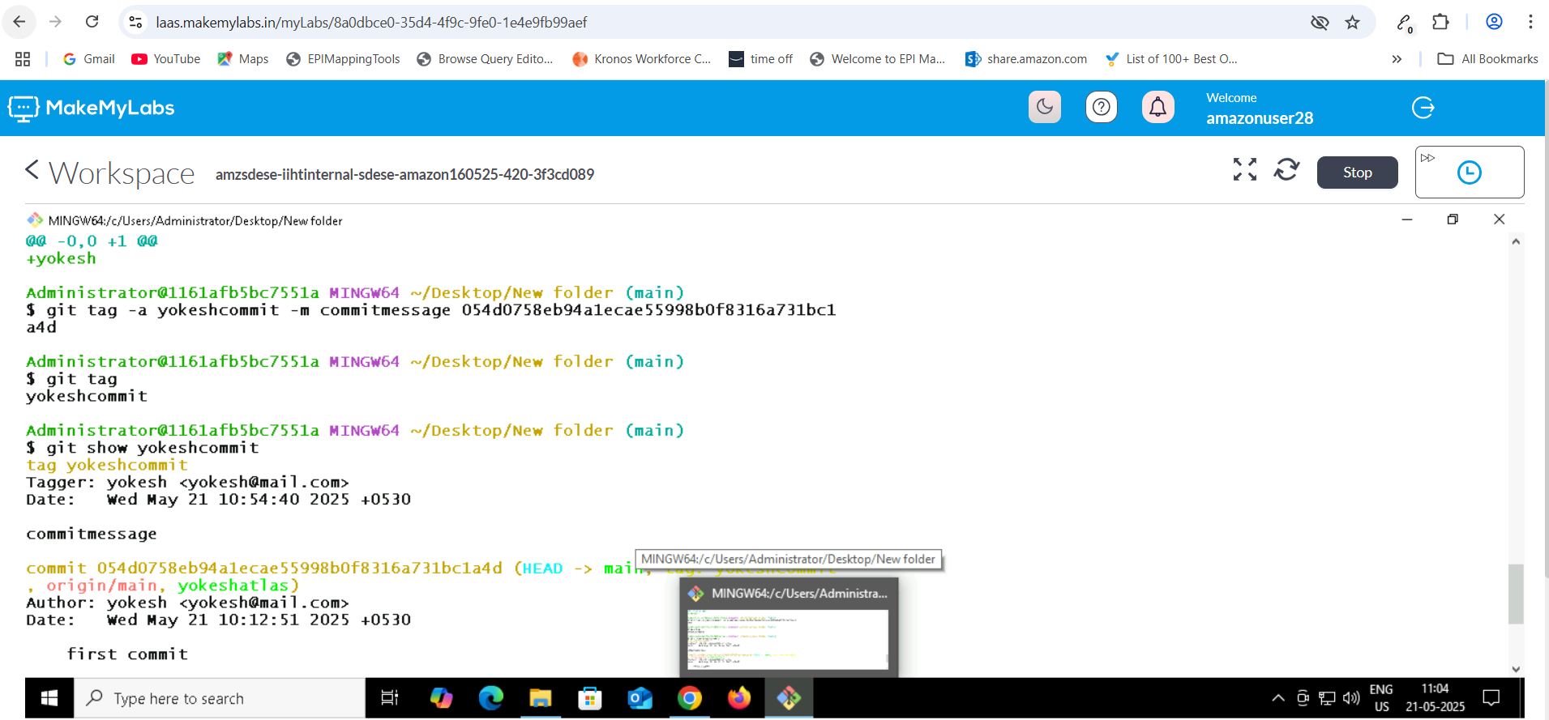

Tag delete

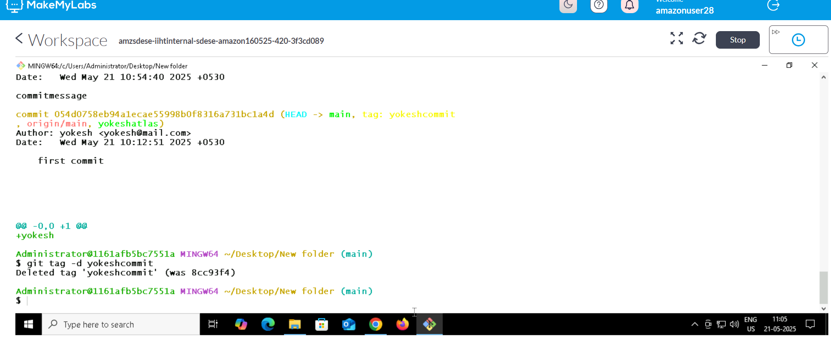

Task 2:

ACID properties

* **Atomicity:**All operations within a transaction are treated as a single unit. Either all operations succeed, or none do, ensuring data consistency.
* **Consistency:**Transactions maintain data integrity by adhering to defined rules and constraints, preventing data corruption.
* **Isolation:**Concurrent transactions are isolated from each other, preventing interference and ensuring data accuracy.
* **Durability:**Once a transaction is committed, the changes are permanent and persist even in the event of system failures.